Rubens’ Tube Standing Sound Wave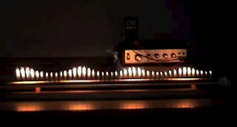
Your Mission!
1. Search and watch a video demonstration of the Rubens’ Tube.
2. Seek out Mrs. H. and demonstrate you know proper handling and safety procedures when using a Rubens’ tube. If this is accomplished you shall get to use the tube.
3. Research what Rubens’ Tube demonstrates. Find all pertinent equations and formulas.
4. Create a lab demonstration that utilizes your research and demonstrates compression and decompression of sound waves in the Rubens’ tube.
5. Demonstrate! (please use appropriate songs) and teach the class about a standing sound wave in a close-end tube.
6. What other places do we see close-end tubes?
7. Become the class experts on Rubens’ tubes and standing sound waves in a close-end system. Teach us what you know.

P.S. If you need access or help to any additional equipment please see Mrs. H.

