Review questions for Light
1. Given a convex mirror with a focus of 3 cm., determine and draw the ray diagram to show the image of an object 4 cm high and 3.5 cm from the mirror.
2. Given a convex mirror with a 4 cm focus, determine and draw the ray diagram to show the image of an object 2 cm high and 2.5 cm away from the mirror.
3. Given a convex mirror with a 4 cm focus determine and draw a ray diagram to show the image of an object 3 cm high and 4 cm away from the mirror.
4. Given a concave mirror with 3.5 cm focus, determine and draw a ray diagram to show the image of an object 3cm high and 4 cm from mirror.
5. Given a concave mirror with a 4 cm focus, determine and draw a ray diagram to show the image of an object 2 cm high and 3 cm from mirror.
6. Draw a vertical plane mirror with an object 6 cm from the mirror. Draw an eye and then draw a ray diagram from that eye to show where the image would be. ( Yours may look different)
7. Given a convex lens with a 3 cm focus, determine and draw the ray diagram to show the image of an object with a height of 3 cm that is 5 cm from the vertical axis of the lens.
8. Given a convex lens with a 3.5 cm focus, determine and draw a ray diagram to show the image of an object with 2 cm height that is 2.5 cm from the vertical axis of the lens.
9. Given a convex lens with 3.5 cm focus, determine and draw a ray diagram to show the image of an object with 1 cm height that is 8 cm from the vertical axis of the lens.
10. Given a convex lens with a 4 cm focus, determine and draw a ray diagram to show the image of an object with 3 cm height that is 3 cm from the vertical axis.
11
Cyan

Red
Yellow
12. Diamond (n = 2.42) How fast does light travel through diamond? If there was a hypothetical diamond wire stretched 2, 562 km how long would it take for light to travel from one end to the other?

13. The speed of light in an unknow medium is 2.62 x 10^8 m/s, what is the material’s index of refraction?
14. The luminosity at a point 4 m away is measured at 6 lumens, what is the luminosity of the source?
15. A source has a flux reading of 87 lumens. I want to know the flux 7 m from the source. What would be the flux reading.
16. What two secondary color filters would be used to make a blue light?
17. Black is the lack of light in primary or secondary?
18. Secondary subtractive
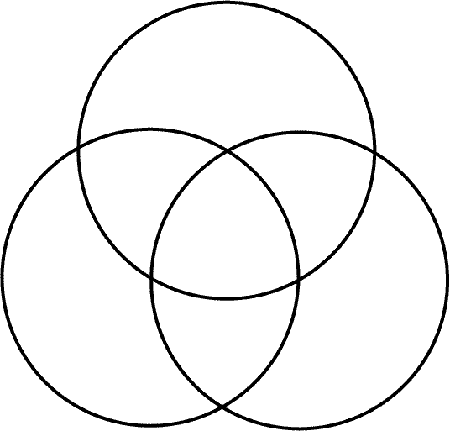
19. Primary additive
20. What is a photon? How does light behave like both a wave and a particle?

,

